How Climate Change May Affect West Nile Spread
Posted: 09/10/2013 10:31 am EDT

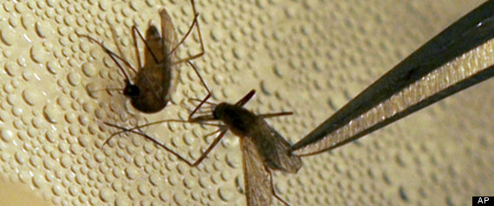
Climate change may have effects on the spread of West Nile virus by mosquitoes, but they're not likely to be the same throughout the United States, according to a new study from University of Arizona researchers.
The study, published in the Proceedings of the National Academy of Sciences, examined the effects of current climate condition predictions on mosquito populations throughout the United States. Researchers found that the effects on mosquito populations are likely to vary depending on the region of country, with mosquito populations actually dropping in the South, but not in the northern part of the U.S.
"One assumption was that with rising temperatures, mosquitoes would thrive across the board," study researcher Cory Morin, who conducted the study as part of his doctoral dissertation at the university, said in a statement. "Our study shows this is unlikely. Rather, the effects of climate change are different depending on the region and because of that, the response of West Nile virus transmitting mosquito populations will be different as well."
The Culex quinquefasciatus mosquito species, which is known to transmit West Nile virus, was examined for the study; it lays eggs in standing water. However, researchers noted that there are other mosquito species that were not examined in the study that also spread West Nile. In addition, birds can spread West Nile virus, though they were not examined in the study.
Researchers found that mosquito populations are likely to vary depending on the part of the U.S. For instance, assuming the southwestern part of the country can expect hotter and drier summers from climate change, the mosquito season will likely be later because of rain in the late summer and fall. However, this could also lead to alonger mosquito season.
In the south and central parts of the United States, on the other hand, climate models show there is likely to be less rain during the summer and early fall seasons. This means there will likely be fewer mosquito days.
The northern parts of the United States will likely still have enough rain and not as extreme of temperatures to decrease summer mosquito breeding.
"'Which locations are likely to experience epidemics in the future?'-- those are the kinds of questions studies like ours may help prepare for," Morin said in the statement. "We don't model the actual virus, we only look at the vector, but our study informs at least one part of the ecology of the virus. It is unique in projecting the impacts of climate change on a West Nile vector."
Last year, the number of people who died in the U.S. from West Nile virus hit record levels, at 286. Nearly a third of serious cases and deaths were in Texas alone, the Associated Press reported. While most people infected with West Nile won't experience symptoms, the approximately 20 percent of people who do can expect have symptoms of vomiting, diarrhea, head and body aches and rash. Rarely, the virus can cause encephalitis or meningitis, which can lead to more serious symptoms and even death, according to the Centers for Disease Control and Prevention.
This isn't the first time climate change has been linked to disease spread. A recent study in the journal Science examined the numerous ways warmer weather is having an impact on ecosystems by affecting biodiversity loss -- and what that could mean for disease spread.
"Biodiversity loss is a well-established consequence of climate change," study researcher Richard Ostfeld, of the Cary Institute of Ecosystem Studies, said in a statement. "In a number of infectious disease systems, such as Lyme disease and West Nile virus, biodiversity loss is tied to greater pathogen transmission and increased human risk. Moving forward, we need models that are sensitive to both direct and indirect effects of climate change on infectious disease."
For a more in-depth look at how climate change might have affected last year's West Nile outbreak, click over to Scientific American's piece here.

